**Objective:**

The Purpose of the application is to take input a particular file in Hindi and convert/ translate it into English or vice versa.

The User should be able to upload the given text in .docx, .pdf, or .txt formats to the web application and output resulting translated document in desired format .doc, .pdf, or .txt.

The User can download the output file.

A text box to copy and paste text is also to be made available for short text translations.

**Requirement Gathering:**

1. **Data sets**
2. **Trained Model**
3. **Firebase- authentication, etc**
4. **Deploy - Heroku**

**Workflow/ Features of the Web Application:**

1. Login to Application
2. Input text file and Download the translated output text file
3. User Log
4. User account settings - photo

**Components:**

1. **UI/UX Component – Web Application- Front end (Sample rough look of pages)**

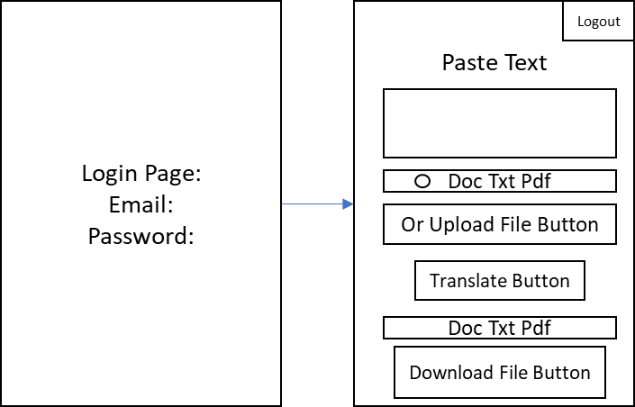

1. **Backend component – Machine Learning Translation Model**

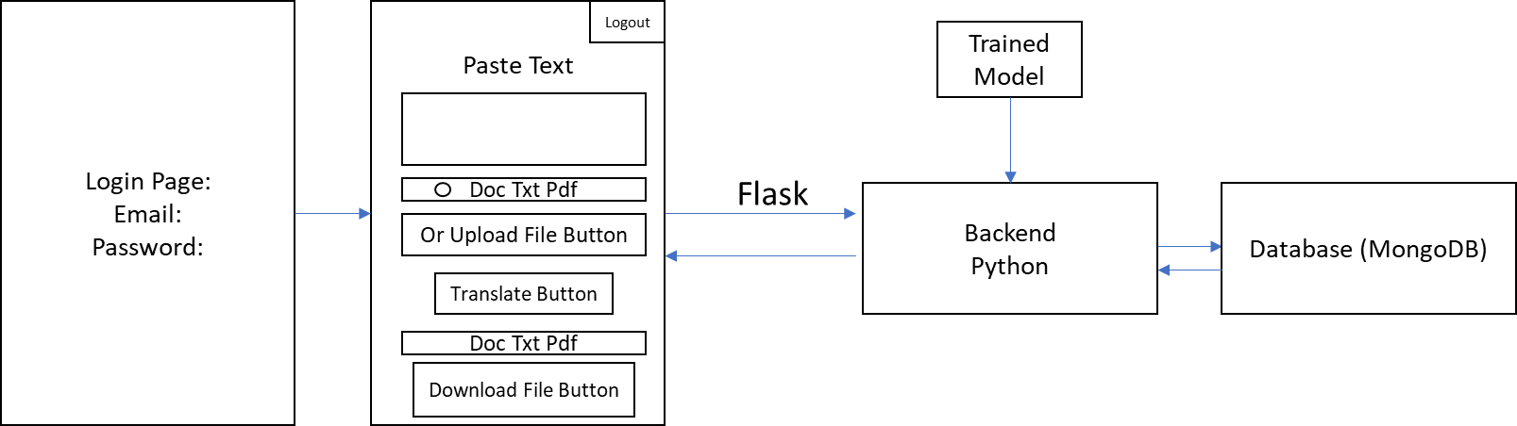

1. **Machine Learning model-**

**Attention mechanisms, RNN, LSTM, (Udemy- course)**

**FlowChart: (Similar to below):**

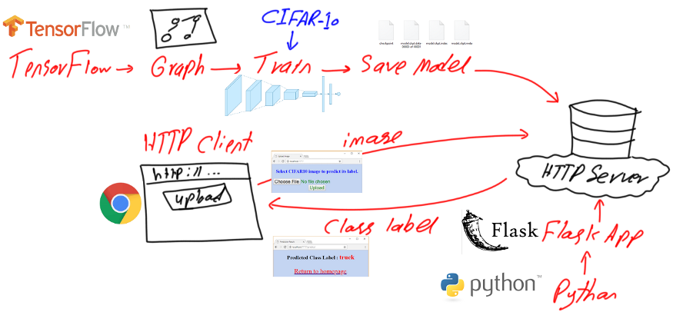

**Database:**

User Name, Email, Password, - Authentication- Firebase

Document, translated document

**Tasks and Subtasks : (Milestoes- Issues- Gitlab-Do) / Trello App - ToDo | In Progress | Completed**

1. **Research-**

**Paper Study- (Link)**

**Paper Study- (Link)**

**Udemy Course – on Attention models**

**Sequence to Sequence models**

**NLP Coursera-**

1. **Frontend (UI/UX)-**

**Page 1**

**Page 2**

1. **Backend-**

**Flask connector**

**DB Setup (User Details and Document Store)**

1. **ML model-**

**Explore Dataset**

**Tokenization**

**Sequence, Padding**